Information Sheet for Face-to-Face Counselling – Covid-19
Note: This is additional to our Counselling Contract
Currently, under the government guidelines, there are a few requirements for us to return to face-to-face sessions.
I will text or email you at least an hour before we are due to meet, asking if either of you have any symptoms of Covid-19 or have been in proximity to anyone who has. I will need a response before we can meet. I will have had a Covid-19 test that morning.

Current BACP/Gov requirement:
09.12.2021 –Masks are to be worn in the buildings and communal areas. As the room is large enough to maintain two meters, masks can be taken off once sat down. As standard hand sanitizer will be available. I will have had a negative lateral flow test that morning or the day before and I will report this in my text. It is of course your choice to wear a mask.
Swan Hill:
Please press the buzzer for Swan Hill Therapy Hub and I will let you in. Make your way up the stairs to the top of the building. I will meet you at the door.
There is water available at the top of the stairs. Please help yourself.
Please do not arrive early for your session as there is nowhere to wait.
The Roy Fletcher Centre:
Please ring the bell to be let into the building. You will either be welcomed in and asked to take a seat in the waiting area, or I will welcome you into the building.
Please use the hand sanitiser provided.
General:
Please note that both rooms are up flights of stairs.
I request that you please bring your own tissues, however in an emergency, I will have spare packets, which I can sanitise before offering to them.
If I am tested positive for Covid-19 then I will be required to share your information as part of the track-and-trace guidelines. I will share only the basic information in order for them to contact you, and explain it is GDPR protected information. I have the NHS track-and-trace app installed and active on my phone. .
If either of us is advised medically to self-isolate, or if one of us has any symptoms of a cold, cough, respiratory issues, or a raised temperature, we will postpone face to face sessions and, where well enough, will have a telephone or online session instead.

This form is for your information. If you do not agree with any of the content or have any questions, please contact me straight away. If I do not hear from you then this will be deemed as acceptance of the information above.
The Rooms
Swan Hill Therapy Hub
On the exterior door, press the intercom for the Therapy Hub and I will buzz you in. Follow the stairs all the way to the top and wait in the area outside of the door. I will meet you there at the agreed time.
Please take your time to review the maps and plan how you intend to come to our session.
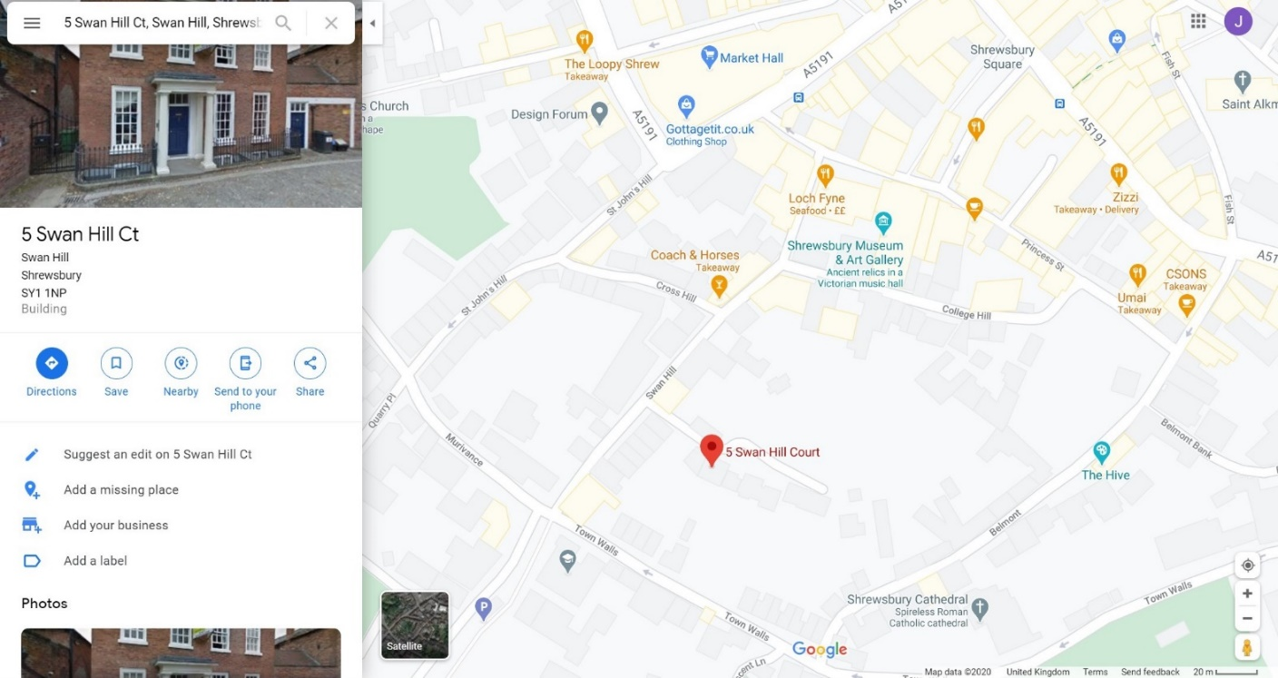
The Roy Fletcher Centre:
Ring the bell or come into the building and take a seat in the waiting area for me to come and greet you.
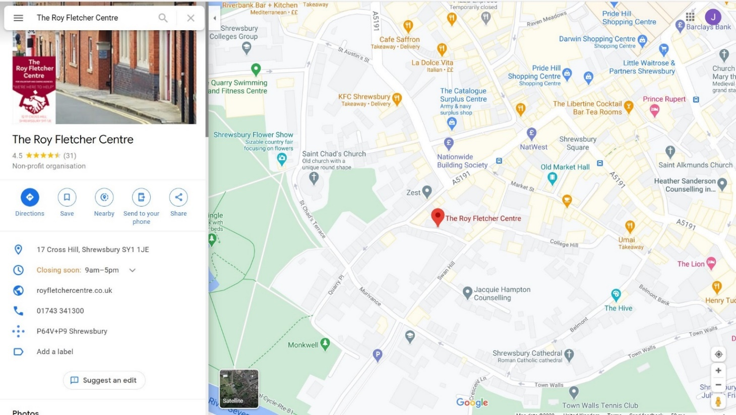
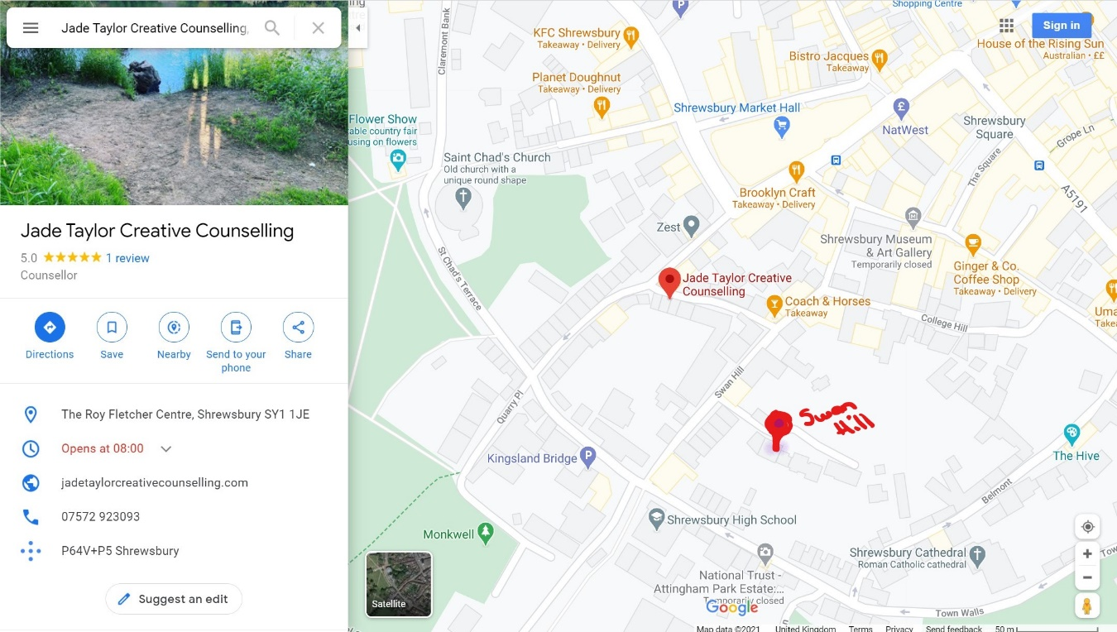
PARKING: I’m afraid there is no parking at either locations. There are nearby car parks. See below.
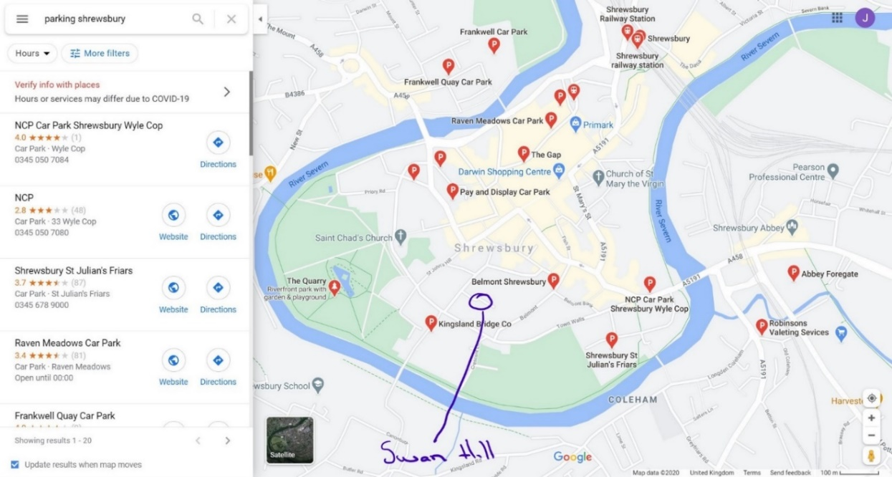

By foot
The quickest route is to park at the Kingsland Bridge and walk to the room. Otherwise, you can come via Lock Fyne, past the Coach and Horses and the room is down the lane to your left. Or via the town walls, or St Johns Street. Take your time to familiarise with the maps provided.

