Information Sheet for Face-to-Face Counselling – Covid-19 - Parents
Note: This is additional to our Counselling Contract
Currently, under the government guidelines, there are a few requirements for us be to face-to-face sessions.
I will text or call you at least an hour before we are due to meet, asking if either of you have any symptoms of Covid-19 or have been in proximity to anyone who has. I will need a response before we can meet. I will have had a Covid-19 test that morning.
Current BACP/Gov requirement:
09.12.2021 –Masks are to be worn in the buildings and communal areas. As the room is large enough to maintain two meters, masks can be taken off once sat down. As standard hand sanitizer will be available. I will have had a negative lateral flow test that morning or the day before and I will report this in my text. It is of course your choice to wear a mask.
Swan Hill:
Please press the buzzer for Swan Hill Therapy Hub and I will let you in. Make your way up the stairs to the top of the building. I will meet you at the door.
There is water available at the top of the stairs. Please help yourself.
Please do not arrive early for your session as there is nowhere to wait.
The Roy Fletcher Centre:
Please ring the bell to be let into the building. You will either be welcomed in and asked to take a seat in the waiting area, or I will welcome you into the building.
Please use the hand sanitiser provided.
General:
Please note: both rooms are up flights of stairs.
I request that you please supply your child with their own tissues, however in an emergency, I will have spare packets, which I can sanitise before offering to them.
I’m afraid there is currently nowhere for parents to wait at Swan Hill due to Covid-19 restrictions. However, you are free to go into Shrewsbury town, wait in the car, or in the small waiting area outside of the hub, where there is one chair. There is a waiting area at the Roy Fletcher Centre.
I will ensure my phone is on at all times in case your Child wants to leave for any reason. I will of course leave with them in any emergency and contact you immediately.
If I am tested positive for Covid-19 then I will be required to share your information as part of the track-and-trace guidelines. I will share only the basic information in order for them to contact you, and explain it is GDPR protected information. I have the NHS track-and-trace app installed and active on my phone.
If any of us are advised to self-isolate, or if one of us has any symptoms of a cold, cough, respiratory issues or a raised temperature, we will postpone face to face sessions and, where well enough, will have a telephone or online session instead.
USING ART/CREATIVE METHODS. For your first time, I will supply your child with their own sketch book. These will be sanitised before being given to them and at the end, will be sealed in a sanitised bag for me to be able to keep their sketch book safe until we meet again. This keeps the drawings and the process within the counselling room. They are of course, welcome to take home any drawings they create or make for someone in particular. They are also more than welcome to bring their own art supplies or anything they wish to show me, I just unfortunately will not be able to use or share with them.
This form is for your information. If you do not agree with any of the content or have any questions, please contact me before we meet. If I do not hear from you then this will be deemed as acceptance of the information above. I request you share this information with your Child.
The Rooms
Swan Hill Therapy Hub
On the exterior door, press the intercom for the Therapy Hub and I will buzz you in. Follow the stairs all the way to the top and wait in the area outside of the door. I will meet you there at the agreed time.
Please take your time to review the maps and plan how you intend to come to our session.
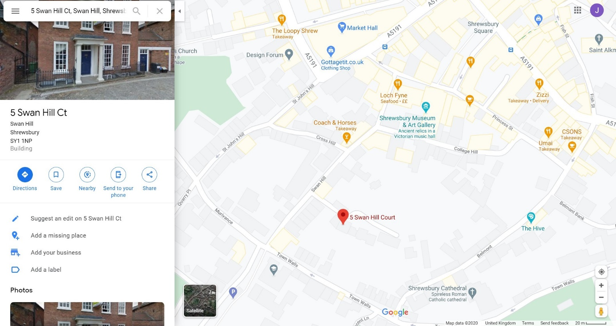
The Roy Fletcher Centre:
Ring the bell or come into the building and take a seat in the waiting area for me to come and greet you.
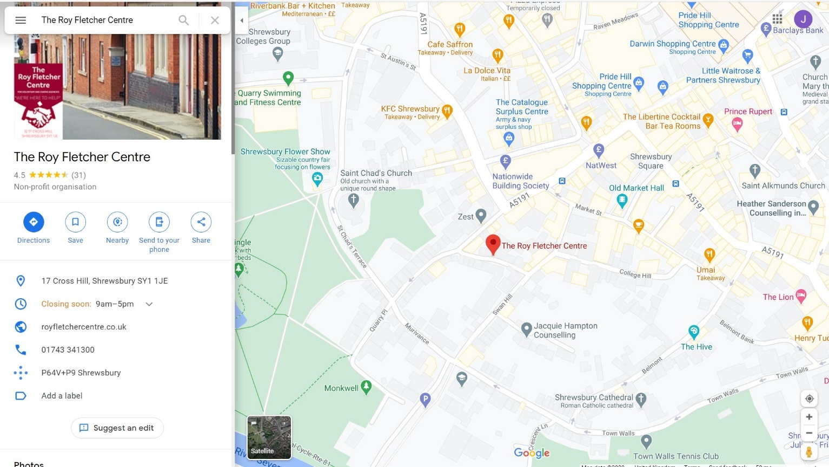
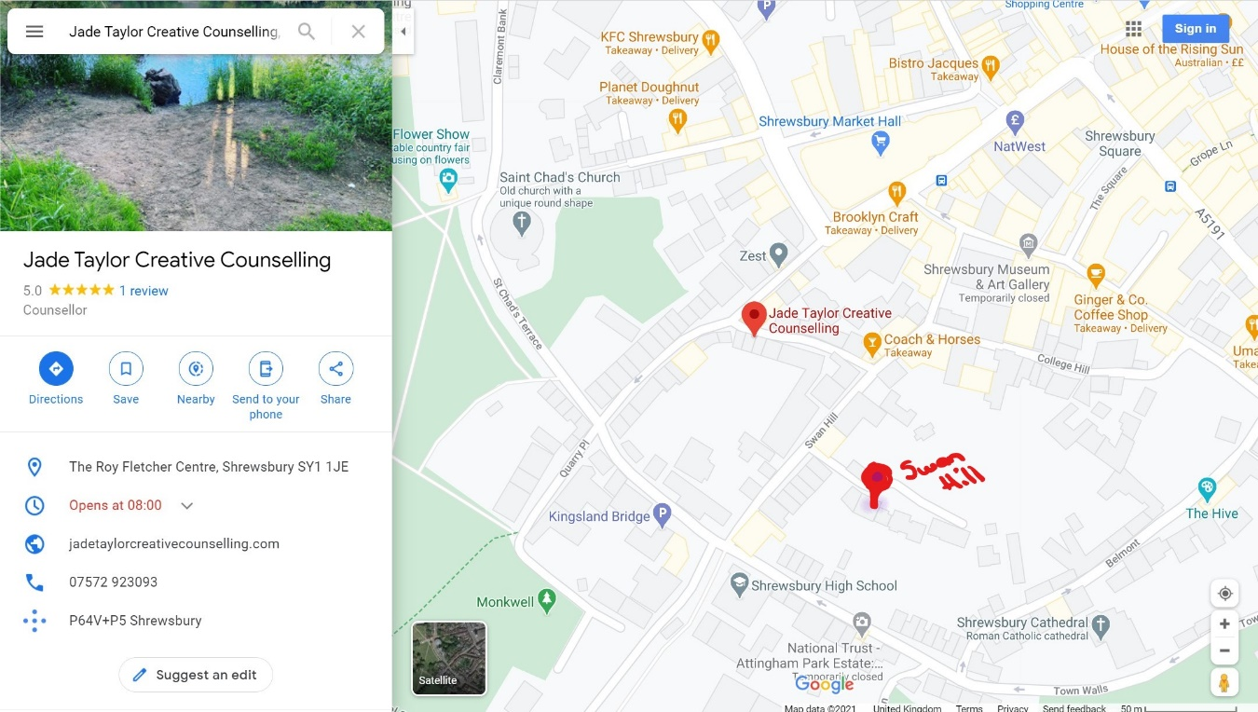
PARKING: I’m afraid there is no parking at either locations. There are nearby car parks. See below.
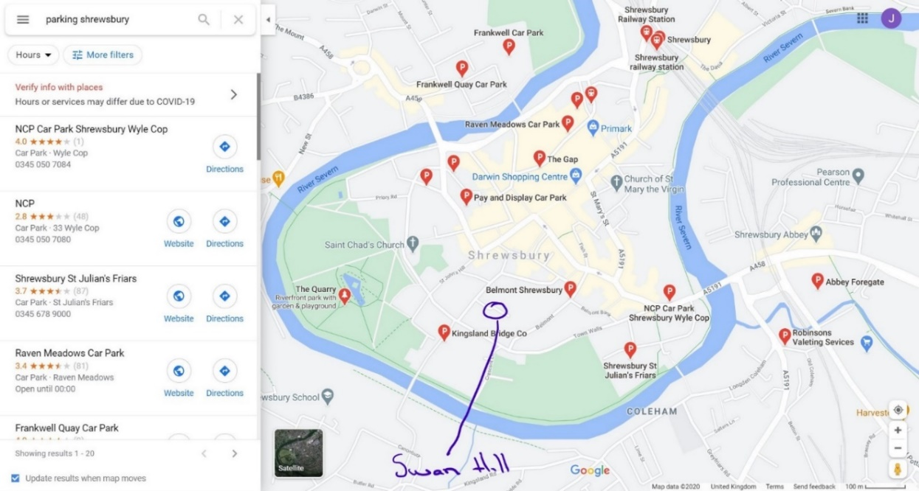

By foot
The quickest route is to park at the Kingsland Bridge and walk to the room. Otherwise, you can come via Lock Fyne, past the Coach and Horses and the room is down the lane to your left. Or via the town walls, or St Johns Street. Take your time to familiarise with the maps provided.
